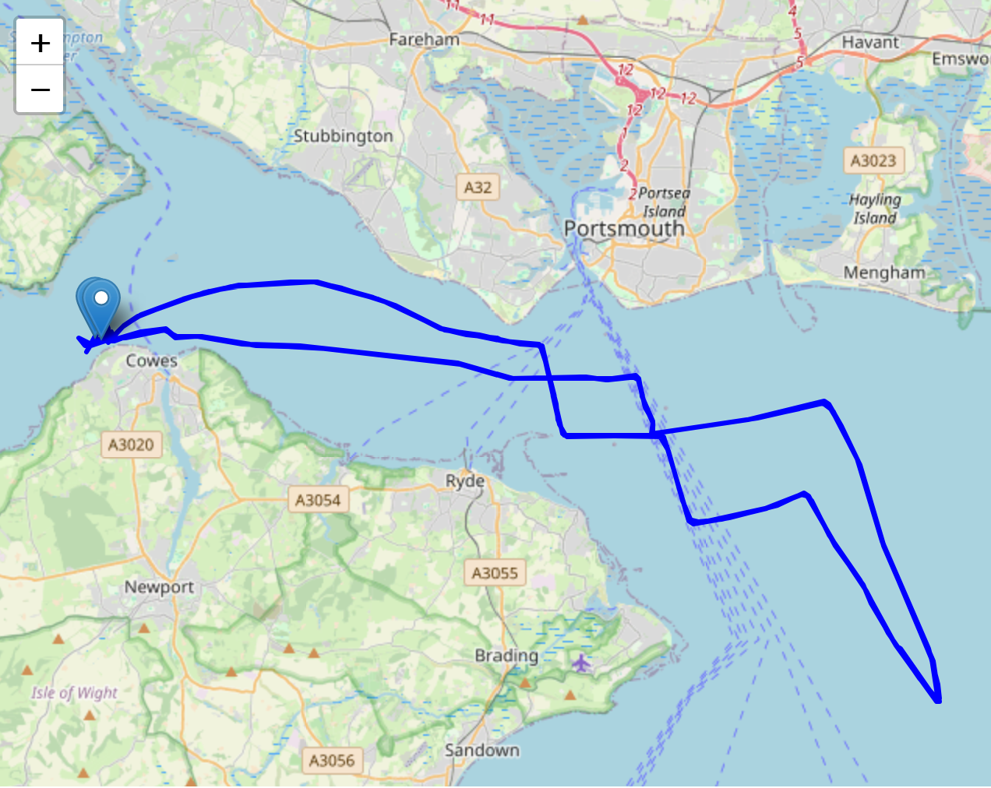
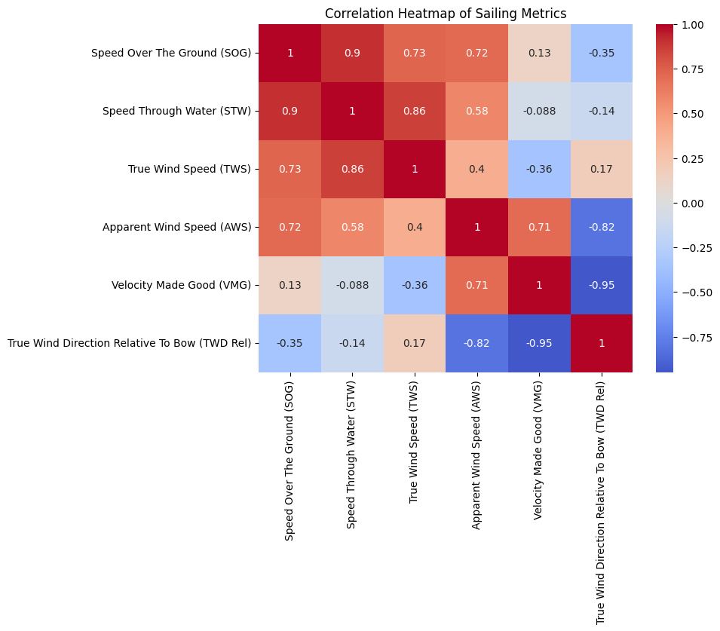
(LEFT) Race course route visualised (start point and end point pinned)

(RIGHT) Correlation between boat speed, wind speed, velocity, wind direction,... visualised
- Boats move faster in stronger winds, and speed through the water translates directly into speed over ground.
So what: The data confirms that wind is the main driver of boat speed — predictable performance increases with wind.
- True and apparent wind influence boat speed and efficiency.
So what: Apparent wind (what the boat actually feels) is important for both speed and effective progress (VMG). Boats that handle apparent wind better perform more efficiently.
- Sailing angle strongly affects progress — VMG decreases when wind direction relative to the bow is less optimal.
So what: Performance isn’t just about going fast; it’s about sailing in the right direction. Correct angle management is critical for efficiency.
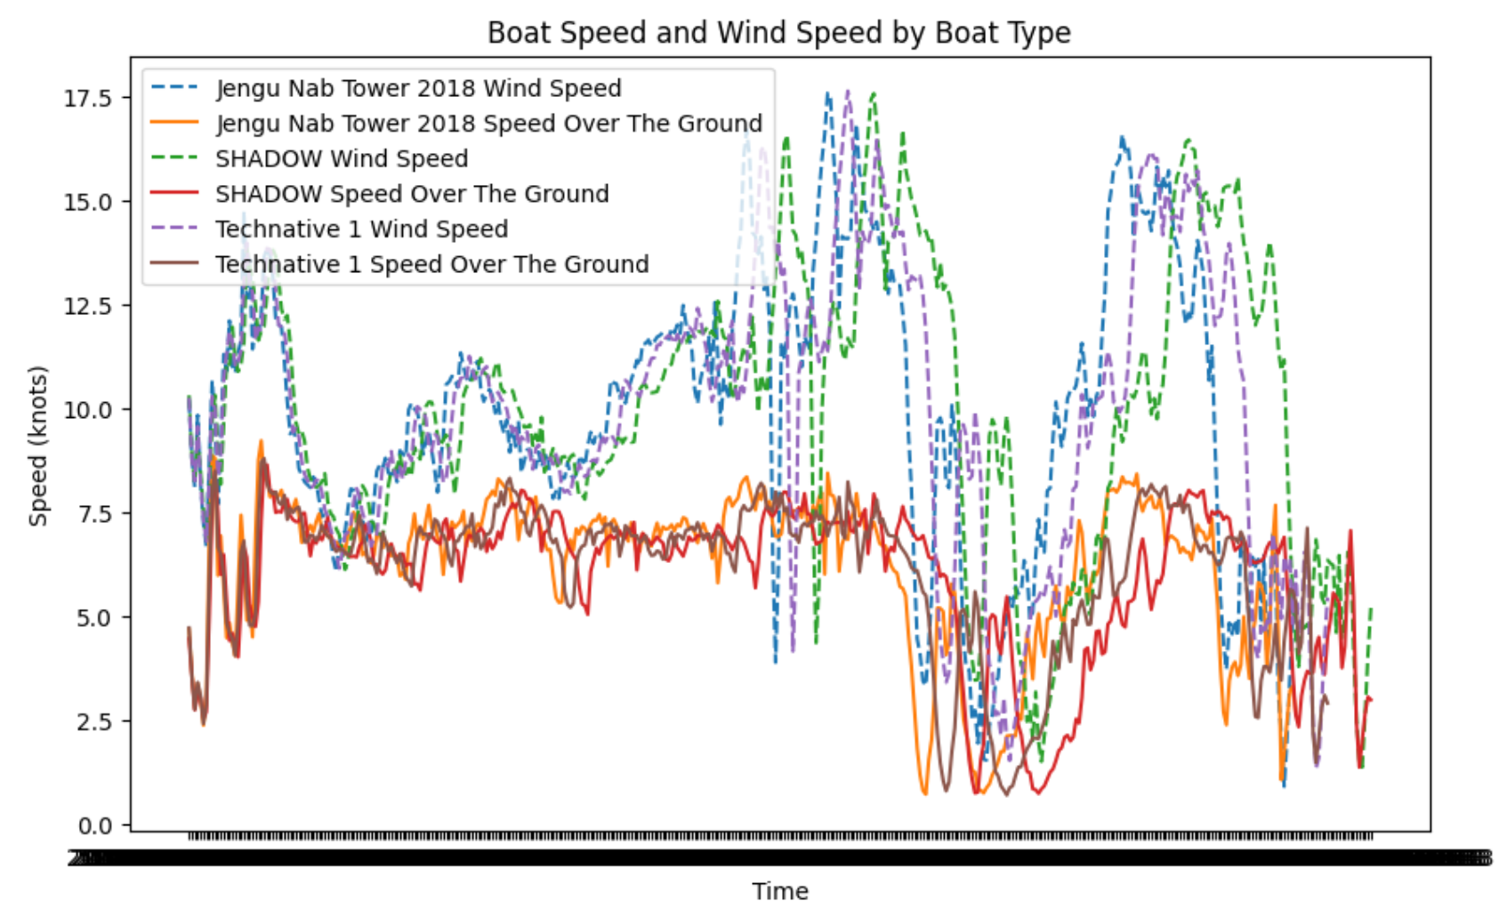
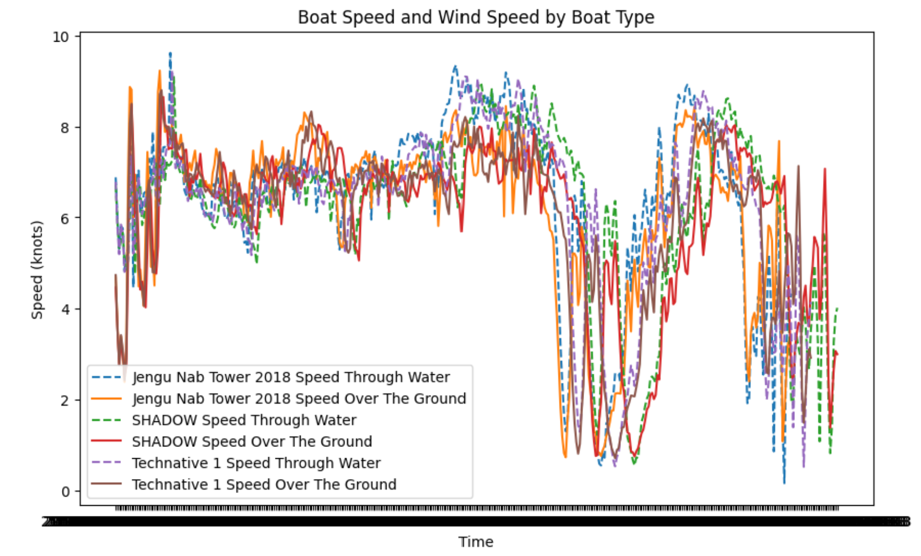

(LEFT) Boat Speed and Wind Speed by Boat Type
(RIGHT) Speed Through Water and Speed Over The Ground by Boat Type
- The ups and downs of boat speeds clearly match and correspond with wind speed. (LEFT)

So what: wind speed directly affects the speed of the boat.

- Comparing speed through water and speed over ground, we can see speed through water is faster than speed over ground, for more than half of the race. (RIGHT)

So what: Because Speed Through Water (STW) is faster than Speed Over The Ground (SOG) when current is moving against the boat, and slower when current is moving with the boat, the data shows that current was mostly moving against the boats in this race, apart from a few moments during the first half of the race, and at the end.

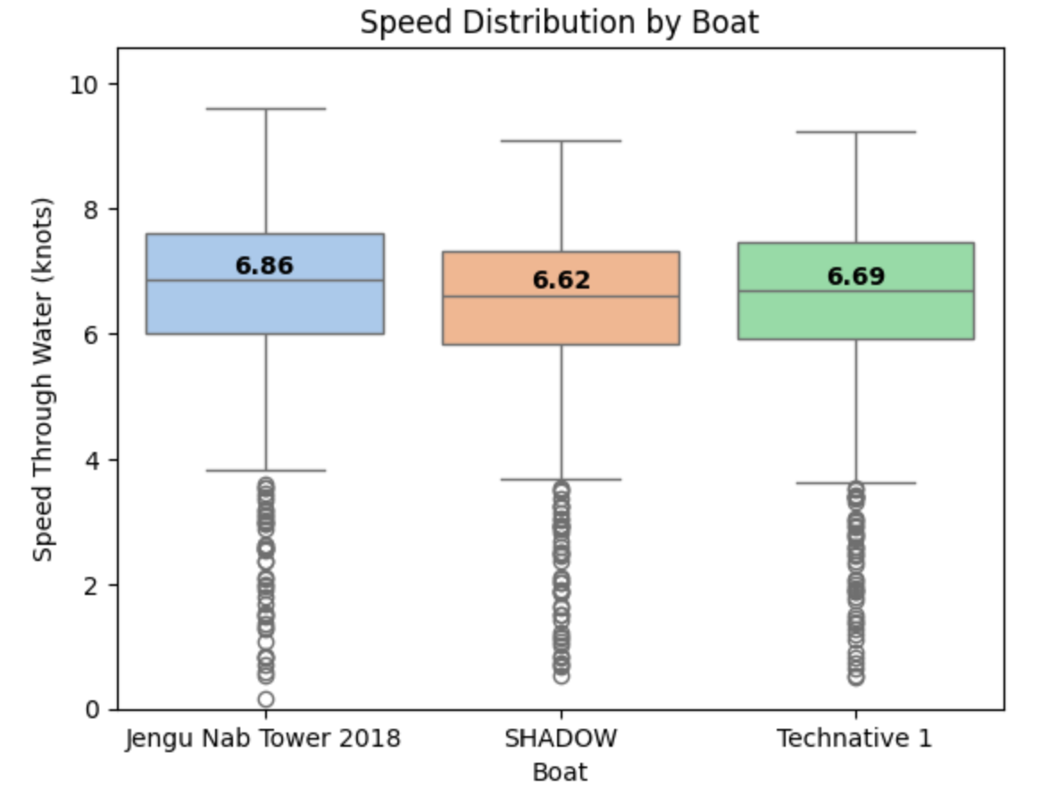
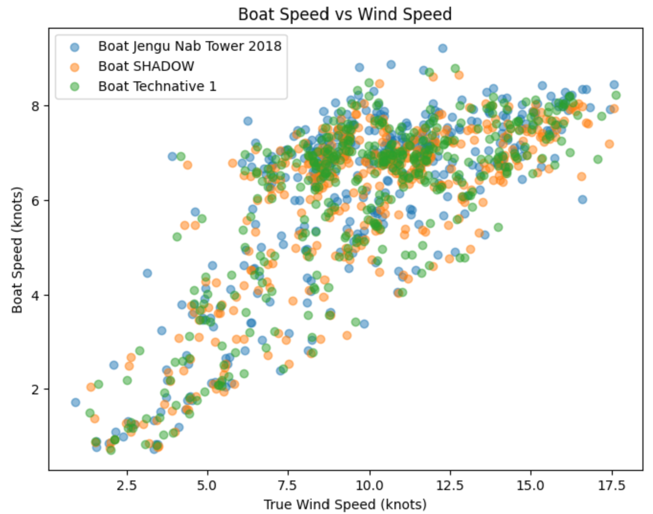

(LEFT) Speed Boxplot by Boat
(RIGHT) Wind Speed by Boat Speed

- Jengu's tail is the longest and SHADOW's tail is the shortest. This suggests Jengu is the most inconsistent with speed. (LEFT)
- The median speed ranking is different from the final ranking of the race. The boats finished the race in the order of Jengu > SHADOW > Technative 1. However, the mean and median speed of Technative 1 is faster than SHADOW. This suggests the data of SHADOW is spread out compared to TechNative 1. (Proven on RIGHT)
So what: A higher average speed does not necessarily translate to better race outcomes, as performance is also influenced by factors such as consistency, sailing efficiency (VMG), and route optimisation.

Summary
★ To maximise performance, a sailor must combine speed, apparent wind, and optimal angle — not just rely on wind strength.
★ A better overall race performance is achievable despite lower average speed, when sailing strategy or optimal positioning is more effective.
2018/04/21 Race Summary
★ Data of SHADOW and Jengu Nab Tower is more spread out compared to Technative 1. This could suggest performance of Technative 1 is consistent and predictable compared to the two other boats — Jengu and SHADOW could be more sensitive to environmental changes such as wind speed.

